V.VAMSIKRISHNA

191131A05P6 CSE 4

Object Oriented Programming Through Java

Lab

**GAYATRI VIDYA PARISHAD COLLEGE OF ENGINEERING**

# (AUTONOMOUS)

**Madhurawada, Visakhapatnam-530048**



**COLLEGE OF ENGINEERING (AUTONOMOUS)**

CERTIFICATE

Certified that this is a bonafide record of practical work done by Roll No

of B.Tech Semester in the Lab , in the Department of

during the academic year .

# No. of Experiments done:

**Signature of Faculty**

**Signature of Internal Examiner: Signature of External Examiner:**

WEEK 1

1a) Implement the following programs using command line arguments i) AIM: Accept two strings from the user and print it on console with concatenation of “and” in the middle of the strings

**Program:**

**public class concat{**

**public static void main(String[] args){**

**String a = args[0];**

**String b = args[1];**

**System.out.println(a+" and "+b);**

**}**

**}**

**Output:**



ii) AIM: Accept 12-hour time zone and convert into its corresponding 24-hour time zone. Note: Accept hours, minutes and seconds separately from the user (e.g 07 05 45 PM should be displayed as 19:05:45)

**Program:**

**public class timeconvert {**

**public static void main(String arg[]){**

**int hrs = Integer.parseInt(arg[0]);**

**int min = Integer.parseInt(arg[1]);**

**int sec = Integer.parseInt(arg[2]);**

**String mer = arg[3];**

**if(mer.equals("PM")||mer.equals("pm")&&hrs!=12)**

**hrs = hrs +12;**

**if(mer.equals("AM")||mer.equals("am")&&hrs==12)**

**hrs = 0;**

**System.out.format("%02d:%02d:%02d",hrs,min,sec);**

**}**

**}**

**Output:**

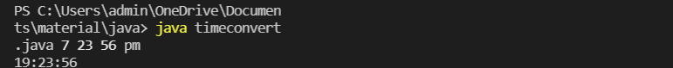

iii) AIM: Accept a number ‘n’ and print the list of ‘n’ Fibonacci terms recursively

**Program:**

**import java.util.Scanner;**

**public class fib1 {**

**public static int  fib_rec(int a)**

**{**

**if(a == 0)**

**{**

**return 0;**

**}**

**else if (a == 1 )**

**{**

**return 1;**

**}**

**else**

**{**

**return (fib_rec(a-2)+fib_rec(a-1));**

**}**

**}**

**public static void main(String[] args) {**

**Scanner s=new Scanner(System.in);**

**int n= Integer.parseInt(args[0]);**

**for(int i=0;i<n;i++)**

**{**

**System.out.print(fib_rec(i)+" ");**

**}**

**s.close();**

**}**

**}**

**Output:**



b) Perform the above programs using Scanner class.

i) AIM: Accept two strings from the user and print it on console with concatenation of “and” in the middle of the strings

**Program:**

**import java.util.Scanner;**

**public class concat{**

**public static void main(String[] args){**

**String str1 = new String();**

**String str2 = new String();**

**Scanner s = new Scanner(System.in);**

**str1 = s.nextLine();**

**str2 = s.nextLine();**

**System.out.println(str1+" and "+str2);**

**s.close();**

**}**

**}**

**Output:**

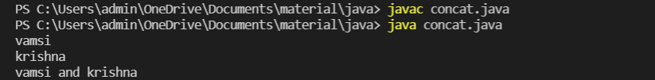

ii) AIM: Accept 12-hour time zone and convert into its corresponding 24-hour time zone. Note: Accept hours, minutes and seconds separately from the user (e.g 07 05 45 PM should be displayed as 19:05:45)

**Program:**

**import java.util.Scanner;**

**public class timeconvert {**

**public static void main(String arg[]){**

**Scanner s = new Scanner(System.in);**

**int hrs = s.nextInt();**

**int min = s.nextInt();**

**int sec = s.nextInt();**

**String mer = s.next();**

**if(mer.equals("PM")||mer.equals("pm")&&hrs!=12)**

**hrs = hrs +12;**

**if(mer.equals("AM")||mer.equals("am")&&hrs==12)**

**hrs = 0;**

**System.out.format("%02d:%02d:%02d",hrs,min,sec);**

**s.close();**

**}**

**}**

**Output:**

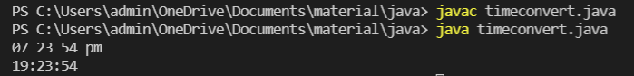

iii) AIM: Accept a number ‘n’ and print the list of ‘n’ Fibonacci terms recursively

**Program:**

**import java.util.Scanner;**

**public class fib1 {**

**public static int  fib_rec(int a)**

**{**

**if(a == 0)**

**{**

**return 0;**

**}**

**else if (a == 1 )**

**{**

**return 1;**

**}**

**else**

**{**

**return (fib_rec(a-2)+fib_rec(a-1));**

**}**

**}**

**public static void main(String[] args) {**

**Scanner s=new Scanner(System.in);**

**System.out.println("enter Number : ");**

**int n=s.nextInt();**

**for(int i=0;i<n;i++)**

**{**

**System.out.print(fib_rec(i)+" ");**

**}**

**s.close();**

**}**

**}**

**Output:**

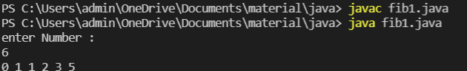

**WEEK2**

a) AIM: Write a program that accepts the set of inputs from the user of various integer data types and determines the primitive data type that is capable of properly storing that input

**Program:**

**import java.util.*;**

**class Main1**

**{**

**public static void main(String args[])**

**{**

**Scanner sc = new Scanner(System.in);**

**System.out.print("Enter Number of inputs : ");**

**int n = sc.nextInt();**

**int i;**

**System.out.println("Enter The Inputs : ");**

**for(i=0;i<n;i++){**

**try{**

**long x = sc.nextLong();**

**System.out.println(x+" can be fitted into :");**

**if(x >= -127 && x <= 128){System.out.println("Byte");}**

**if(x >= Short.MIN_VALUE && x <= Short.MAX_VALUE){System.out.println("Short");}**

**if(x >= Long.MIN_VALUE && x <= Long.MAX_VALUE){System.out.println("Long");}**

**if(x >= Integer.MIN_VALUE && x >= Integer.MAX_VALUE){System.out.println("Integer");}**

**}**

**catch(Exception x){**

**System.out.println(sc.next()+" cannot be fitted into Available DataTypes");**

**}}**

**sc.close();**

**}**

**}**

**output:**

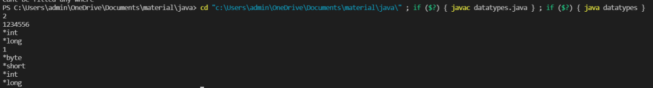

b) AIM: Write a program that accepts an array of integers and print those which are both odd and prime. If no such element in that array print “Not found”.

**Program:**

**import java.util.Scanner;**

**public class oddprime {**

**public static void main(String s[]){**

**int n;**

**Scanner sc = new Scanner(System.in);**

**System.out.println("enter the no of elements");**

**n = sc.nextInt();**

**int[] arr = new int[n];**

**System.out.println("enter the numbers");**

**for(int i=0;i<n;i++){**

**arr[i] = sc.nextInt();**

**}**

**for(int i=0;i<n;i++){**

**if(arr[i]%2!=0){**

**int c=0;**

**for(int j = 1;j<=arr[i];j++){**

**if(arr[i]%j==0){**

**c +=1;**

**}**

**}**

**if(c==2){**

**System.out.println(arr[i]+" is odd and a prime number");**

**}**

**}**

**}**

**sc.close();**

**}**

**}**

**output:**

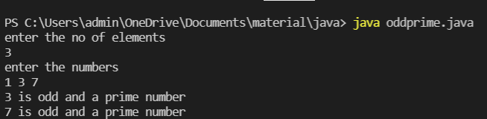

c) AIM: Write a program to accept contents into an Integer Array and print the frequency of each number in the order of their number of occurrences.

**Program:**

**import java.util.*;**

**public class Frequency{**

**public static void main(String args[]){**

**Scanner sc = new Scanner(System.in);**

**int s = sc.nextInt(),visited = -1;**

**int arr[] = new int[s];**

**int visited_arr[] = new int[s];**

**for(int i = 0;i<s;i++)**

**arr[i] = sc.nextInt();**

**for(int i = 0;i<s;i++){**

**int count = 1;**

**for(int j = i+1; j< s;j++){**

**if(arr[i] == arr[j]){**

**count++;**

**visited_arr[j] = visited;**

**}**

**}**

**if(visited_arr[i]!=visited)**

**visited_arr[i] = count;**

**}**

**for(int i = 0; i < s ; i++){**

**for(int j=0;j<s-i-1;j++){**

**if(visited_arr[j] > visited_arr[j+1] ){**

**int temp;**

**temp = visited_arr[j];**

**visited_arr[j] = visited_arr[j+1];**

**visited_arr[j+1] = temp;**

**temp = arr[j];**

**arr[j] = arr[j+1];**

**arr[j+1] = temp;**

**}**

**}**

**}**

**for(int i=s-1;i>0;i--){**

**if(visited_arr[i] != visited){**

**System.out.println(arr[i]+" - "+visited_arr[i]);**

**}**

**}**

**sc.close();**

**}**

**}**

**Output:**

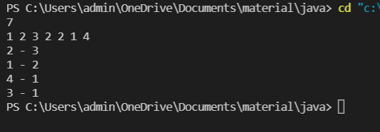

**Week 3**

1. AIM: Write a program that accepts an „n‟ ordered square matrix elements into a single dimension array and print the elements of leading diagonal (top left to bottom right).

**Program:**

**import java.util.Scanner;**

**class DiagonalMatrix**

**{**

**static int MAX = 100;**

**static void printPrincipalDiagonal(int mat[][],int m, int n)**

**{**

**System.out.print("Principal Diagonal: ");**

**for (int i = 0; i < m; i++) {**

**for (int j = 0; j < n; j++) {**

**if (i == j) {**

**System.out.print(mat[i][j] + ", ");**

**}**

**}**

**}**

**System.out.println("");**

**}**

**static void printSecondaryDiagonal(int mat[][], int m,int n)**

**{**

**System.out.print("Secondary Diagonal: ");**

**for (int i = 0; i < m; i++) {**

**for (int j = 0; j < n; j++) {**

**if ((i + j) == (n - 1)) {**

**System.out.print(mat[i][j] + ", ");**

**}**

**}**

**}**

**System.out.println("");**

**}**

**public static void main(String args[])**

**{**

**int m,n,i,j;**

**Scanner sc = new Scanner(System.in);**

**System.out.println("enter no of rows");**

**m = sc.nextInt();**

**System.out.println("enter no of columns");**

**n = sc.nextInt();**

**int a[][] = new int[m][n];**

**System.out.println("enter no of elements in the matrix");**

**for(i=0;i<m;i++) {**

**for(j=0;j<n;j++)**

**{**

**a[i][j]=sc.nextInt();**

**}**

**}**

**printPrincipalDiagonal(a,m, n);**

**printSecondaryDiagonal(a,m, n);**

**}**

**}**

**Output:**

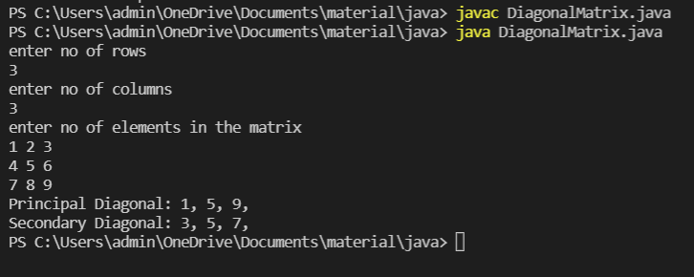

1. AIM: Write a program that accepts an ‘m x n’ double dimension array, where ‘m’ represents financial years and ‘n’ represents Ids of the items sold. Each element in the array represents the number of items sold in a particular year. Identify the year and id of the item which has more demand.

**Program:**

**import java.util.Scanner;**

**public class yearitems {**

**public static void main(String[] args) {**

**int m,n,max,y=0,id=0,i,j;**

**Scanner s =new Scanner(System.in);**

**System.out.println("enter the number of Years: ");**

**m=s.nextInt();**

**System.out.println("enter the number of Items : ");**

**n=s.nextInt();**

**int a[][] = new int[m][n];**

**System.out.println("enter the matrix : ");**

**for(i=0;i<m;i++)**

**{**

**for(j=0;j<n;j++)**

**{**

**a[i][j]=s.nextInt();**

**}**

**}**

**max=a[0][0];**

**for(i=0;i<m;i++)**

**{**

**for(j=0;j<n;j++)**

**{**

**if(max<a[i][j])**

**{**

**max=a[i][j];**

**y=i;**

**id=j;**

**}**

**}**

**}**

**System.out.println("Item with ID : "+(id+1) + " has more demand in Year : "+(y+1));**

**s.close();**

**}**

**}**

**Output:**

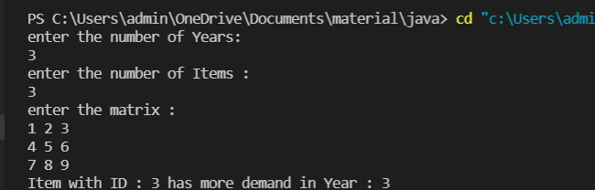

1. AIM: Write a program that accepts an „n‟ ordered square matrix and calculate the absolute difference between the sums of elements in their diagonals.

**Program:**

**import java.util.Scanner;**

**public class pricidiagsum {**

**static void diagsum(int a[][], int m, int n){**

**int sum1 = 0,sum2 = 0;**

**for(int i=0;i<m;i++){**

**for(int j=0;j<n;j++){**

**if(i==j){**

**sum1 += a[i][j];**

**}**

**if(i+j==n-1){**

**sum2 += a[i][j];**

**}**

**}**

**}**

**System.out.println("Principal diaognal sum is "+sum1);**

**System.out.println("Secondary diaognal sum is "+sum2);**

**if(sum1>sum2){**

**System.out.println("Difference is "+(sum1-sum2));**

**}**

**else{**

**System.out.println("Difference is "+(sum2-sum1));**

**}**

**}**

**public static void main(String s[]){**

**int m,n,i,j;**

**Scanner sc = new Scanner(System.in);**

**System.out.println("enter no of rows");**

**m = sc.nextInt();**

**System.out.println("enter no of columns");**

**n = sc.nextInt();**

**int a[][] = new int[m][n];**

**System.out.println("enter no of elements in the matrix");**

**for(i=0;i<m;i++) {**

**for(j=0;j<n;j++)**

**{**

**a[i][j]=sc.nextInt();**

**}**

**}**

**diagsum(a,m,n);**

**sc.close();**

**}**

**}**

**Output:**

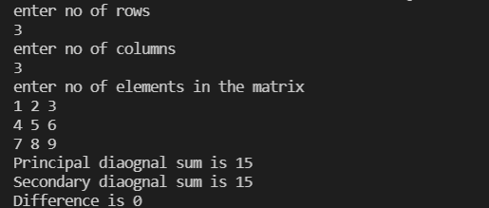

**WEEK 04**

PROGRAM ((a)) :

AIM : Create a class Box that uses a parameterized constructor to initialize the dimensions of a

box. The dimensions of the Box are width, height, depth. The class should have a method that

can return the volume of the box. Create an object of the Box class and test the functionality.

PROGRAM :

**import java.util.Scanner;**

**class Box{**

**int height,width,length;**

**Box(int h,int w,int l){**

**this.height = h;**

**this.width = w;**

**this.length = l;**

**}**

**int vol(){**

**return height*width*length;**

**}**

**}**

**class week4a{**

**public static void main(String s[]){**

**Scanner sc = new Scanner(System.in);**

**int height = sc.nextInt();**

**int width = sc.nextInt();**

**int length = sc.nextInt();**

**Box b = new Box(height,width,length);**

**int vol = b.vol();**

**System.out.println("volume of the box is "+vol);**

**sc.close();**

**}**

**}**

INPUT AND OUTPUT :

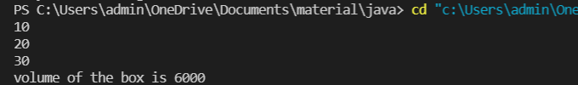

PROGRAM ((b)) :

AIM : Create a new class called Calculator with the following methods:

o A static method called powerInt(int num1,int num2)

This method should return num1 to the power num2.

o A static method called powerDouble(double num1,double num2).

This method should return num1 to the power num2.

o Invoke both the methods and test the functionality. Also count the number of objects

created.

PROGRAM :

**import java.util.* ;**

**class week4b {**

**static int powerInt(int num1,int num2){**

**int p = 1;**

**for(int i=0; i<num2;i++){**

**p = p*num1;**

**}**

**return p;**

**}**

**static double powerDouble(double num1,int num2){**

**double p = 1;**

**for(int i=0; i<num2;i++){**

**p = p*num1;**

**}**

**return p;**

**}**

**public static void main(String args[])**

**{**

**Scanner s = new Scanner(System.in);**

**int n1 = s.nextInt();**

**int n2 = s.nextInt();**

**double dn1 = s.nextDouble();**

**int dn2 = s.nextInt();**

**int n = powerInt(n1,n2);**

**System.out.println("power(int) is "+n);**

**double dn = powerDouble(dn1,dn2);**

**System.out.println("power(double) is "+dn);**

**s.close();**

**}**

**}**

INPUT AND OUTPUT :

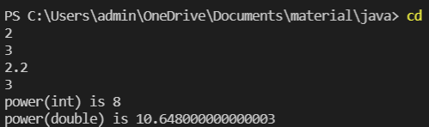

WEEK 05

PROGRAM ((a)) :

AIM : Accept a String and a number „n‟ from user. Divide the given string into substrings each of

size „n‟ and sort them lexicographically.

**import java.util.*;**

**class week5a{**

**static void divstring(String str,int n){**

**int i,l = str.length();**

**if(l%n!=0){**

**System.out.println("cannot divide");**

**}**

**else{**

**for( i=0;i<l;i++){**

**if(i%n==0)**

**System.out.println();**

**System.out.print(str.charAt(i));**

**}**

**}**

**return;**

**}**

**public static void main(String s[]){**

**Scanner sc = new Scanner(System.in);**

**String str = sc.nextLine();**

**int n = sc.nextInt();**

**divstring(str,n);**

**sc.close();**

**}**

**}**

INPUT AND OUTPUT :

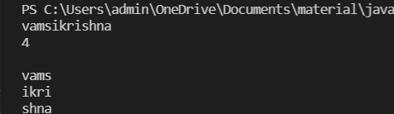

PROGRAM ((b)) :

AIM : Accept an array of strings and display the number of vowels and consonants occurred in each string.

PROGRAM :

**import java.util.Scanner;**

**public class week5b {**

**static void vc(String str){**

**int c=0,v=0,l = str.length();**

**char ch;**

**str = str.toUpperCase();**

**for(int i=0;i<l;i++){**

**ch = str.charAt(i);**

**if(ch=='A'||ch=='E'||ch=='I'||ch=='O'||ch=='U')**

**v++;**

**else**

**c++;**

**}**

**System.out.println("vowel count is "+v);**

**System.out.println("consonant count is "+c);**

**}**

**public static void main(String s[]){**

**Scanner sc = new Scanner(System.in);**

**String str = sc.nextLine();**

**vc(str);**

**sc.close();**

**}**

**}**

INPUT AND OUTPUT :

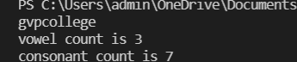

PROGRAM ((c)) :

AIM : Accept two strings from the user and determine if the strings are anagrams or not.

PROGRAM :

**import java.util.Scanner;**

**public class week5c {**

**static void anagram(String s1,String s2){**

**char str1[] = s1.toLowerCase().toCharArray();**

**char str2[] = s2.toLowerCase().toCharArray();**

**java.util.Arrays.sort(str1);**

**java.util.Arrays.sort(str2);**

**if(java.util.Arrays.equals(str1,str2)){**

**System.out.println("They are Anagrams");**

**}**

**else{**

**System.out.println("They are not Anagrams");**

**}**

**}**

**public static void main(String s[]){**

**Scanner sc = new Scanner(System.in);**

**String s1 = sc.nextLine();**

**String s2 = sc.nextLine();**

**anagram(s1,s2);**

**sc.close();**

**}**

**}**

INPUT AND OUTPUT :



**Week 6**

PROGRAM (A): -

AIM: Create a multilevel inheritance for classes vehicle, brand and cost. The vehicle class determines the type of vehicle which is inherited by the class brand which determines the brand of the vehicle. Brand class is inherited by cost class, which tells about the cost of the vehicle. Create another class which calls the constructor of cost class and method that displays the total vehicle information from the attributes available in the super classes.

PROGRAM:

**class  week61 {**

**public static void main(String args[]){**

**Cost c1 = new Cost();**

**c1.display();**

**}}**

**class Vehicle{**

**String Vehicle = "Car";**

**}**

**class Brand extends Vehicle{**

**String B0 = "Ferrari Portofino";**

**String B1 = "BMW X3";**

**String B2 = "Mercedes A-Class Limousine";**

**String B3 = "Audi RS";**

**String B4 = "Skoda Octavia";**

**}**

**class Cost extends Brand{**

**String C0 = "3 Crore";**

**String C1 = "60 Lakh";**

**String C2 = "55 Lakh";**

**String C3 = "2 Crore";**

**String C4 = "30 Lakh";**

**void display(){**

**System.out.print("\nVehicle : "+Vehicle+" BrandName : "+B0+" cost : "+C0);**

**System.out.print("\nVehicle : "+Vehicle+" BrandName : "+B1+" cost : "+C1);**

**System.out.print("\nVehicle : "+Vehicle+" BrandName : "+B2+" cost : "+C2);**

**System.out.print("\nVehicle : "+Vehicle+" BrandName : "+B3+" cost : "+C3);**

**System.out.print("\nVehicle : "+Vehicle+" BrandName : "+B4+" cost : "+C4);**

**}}**

OUTPUT:

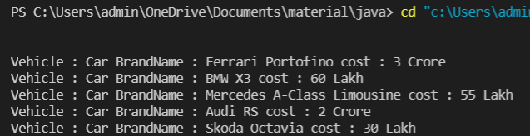

PROGRAM (B): -

AIM: Create an inheritance hierarchy of Figure_3D, Cylinder, Cone, Sphere etc. In the base class and provide methods that are common to all Figure_3Ds and override these in the derived classes to perform different behaviors, depending on the specific type of Figure_3D. Create an array of Figure_3D, fill it with different specific types of Figure_3Ds and call your base class methods

PROGRAM:

**public class week62 {**

**public static void main(String arg[]){**

**Figure_3D[] fig = new Figure_3D[7];**

**fig[0] = new Cylinder();**

**fig[1] = new Cone();**

**fig[2] = new Sphere();**

**fig[3] = new Cube();**

**fig[4] = new Rectangle();**

**fig[5] = new Square();**

**fig[6] = new Triangle();**

**fig[0].volume();**

**fig[1].volume();**

**fig[2].volume();**

**fig[3].volume();**

**fig[4].area();**

**fig[5].area();**

**fig[6].area();**

**}**

**}**

**class Figure_3D{**

**void volume(){**

**System.out.println("\nVolume of a 3D Figure = (Length*Breadth*Height)");**

**}**

**void area(){**

**System.out.println("\nArea of a 2D Figure is : (Length*Breadth)");**

**}**

**}**

**class Cylinder extends Figure_3D{**

**void volume(){**

**double r = 10.0,h = 15.0;**

**System.out.print("\nVolume of Cylinder is : "+(3.14*r*r*h));**

**}**

**}**

**class Cone extends Figure_3D{**

**void volume(){**

**double r = 10.0,h = 15.0;**

**System.out.print("\nVolume of Cone is : "+((3.14*r*r*h)/3));**

**}**

**}**

**class Sphere extends Figure_3D{**

**void volume(){**

**double r = 10.0;**

**System.out.print("\nVolume of Sphere is : "+((4*3.14*r*r*r)/3));**

**}**

**}**

**class Cube extends Figure_3D{**

**void volume(){**

**double a = 10.0;**

**System.out.print("\nVolume of Cube is : "+(a*a*a));**

**}**

**}**

**class Rectangle extends Figure_3D{**

**void area(){**

**double l = 10.0,b = 15.0;**

**System.out.print("\nArea of Rectangle is : "+(l*b));**

**}**

**}**

**class Square extends Figure_3D{**

**void area(){**

**double s = 10.0;**

**System.out.print("\nArea of Square is : "+(s*s));**

**}**

**}**

**class Triangle extends Figure_3D{**

**void area(){**

**double base = 10.0,h = 15.0;**

**System.out.print("\nArea of Triangle is : "+((base*h)/2));**

**}**

**}**

OUTPUT:

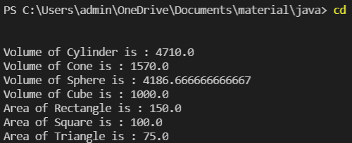

**Week 7**

PROGRAM (A): -

AIM: Design a package to contain the class Student that contains data members such as name, roll number and another package contains the interface Sports which contains some sports information. Import these two packages in a package called Report which process both Student and Sport and give the report.

PROGRAM:

**package pack1;**

**public class week71p{**

**public String name = "vamsi" ;**

**public String rollno = "19131A05P6" ;**

**public String branch = "cse" ;**

**public String section = "4" ;**

**}**

**package report;**

**import pack1.*;**

**public class pack implements sports{**

**public void show(){**

**String Sport1 = "Football";**

**String Sport2 = "Cricket";**

**System.out.println("Sport1 : "+Sport1);**

**System.out.println("Sport2 : "+Sport2);**

**}**

**}**

**package pack1;**

**public interface sports {**

**void show();**

**}**

**import report.*;**

**import pack1.*;**

**public class week71 {**

**public static void main(String s[]){**

**week71p student = new week71p();**

**sports sp = new pack();**

**System.out.println("Name : "+student.name);**

**System.out.println("RollNo : "+student.rollno);**

**System.out.println("Branch : "+student.branch);**

**System.out.println("Section : "+student.section);**

**sp.show();**

**}**

**}**

OUTPUT:

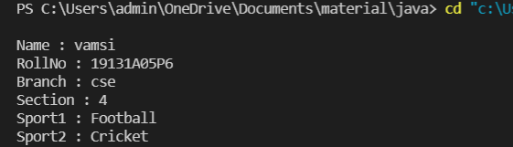

PROGRAM (B): -

AIM: Write a program that accepts values of different data types and convert them to corresponding wrapper classes and display using the vector

PROGRAM:

**import java.util.*;**

**import java.io.*;**

**public class week72{**

**public static void main(String args[]){**

**byte a=1;**

**short b=25;**

**int c=380;**

**long d=4000;**

**float e=59.0F;**

**double f=680.0D;**

**char g='V';**

**boolean h=false;**

**Byte byteobj=a;**

**Short shortobj=b;**

**Integer intobj=c;**

**Long longobj=d;**

**Float floatobj=e;**

**Double doubleobj=f;**

**Character charobj=g;**

**Boolean boolobj=h;**

**Vector  v = new Vector ();**

**v.add(byteobj);**

**v.add(shortobj);**

**v.add(intobj);**

**v.add(longobj);**

**v.add(floatobj);**

**v.add(doubleobj);**

**v.add(charobj);**

**v.add(boolobj);**

**Iterator itr=v.iterator();**

**while(itr.hasNext()){**

**System.out.println(itr.next());}**

**}}**

OUTPUT:

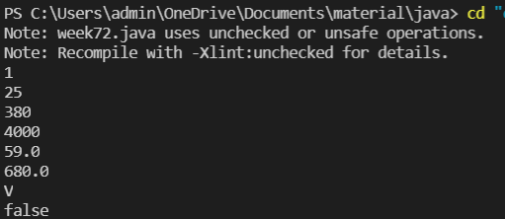

**Week 8**

PROGRAM (A): -

AIM: Write a program to generate a set of random numbers between two numbers x1 and x2, and x1>0.

PROGRAM:

**import java.util.*;**

**class week8a**

**{**

**public static void main(String str[])**

**{**

**Scanner sc = new Scanner(System.in);**

**System.out.println("number of values: ");**

**int number = sc.nextInt();**

**System.out.println("Enter starting number ");**

**int start = sc.nextInt() ;**

**System.out.println("Enter ending number ");**

**int end = sc.nextInt();**

**Random rand = new Random();**

**int r;**

**System.out.println("Random numbers ");**

**for(int i=1;i<=number;i++)**

**{**

**r = rand.nextInt(end-start+1)+start;**

**System.out.println(r);**

**}**

**sc.close();**

**}**

**}**

OUTPUT:

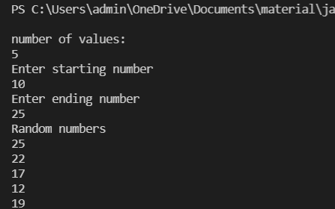

PROGRAM (B): -

AIM: Write a program to implement a new ArrayList class. It should contain add(), get(), remove(), size() methods. Use dynamic array logic.

PROGRAM: **import java.util.*;**

**class week8b{**

**public static void main(String s[]){**

**ArrayList<String> arr=new ArrayList<String>();**

**arr.add("javalab");**

**arr.add("arraylist");**

**arr.add("week8");**

**arr.add("iterator");**

**arr.add("concepts");**

**Iterator itr=arr.iterator();**

**System.out.println("contents of arraylist ");**

**while(itr.hasNext())**

**System.out.println(itr.next());**

**System.out.println("4th Element in list "+arr.get(3)+" and it is removed");**

**arr.remove(3);**

**System.out.println("After removing array list elements");**

**Iterator i=arr.iterator();**

**while(i.hasNext())**

**{**

**System.out.println(i.next());**

**}**

**System.out.println("size of Array List after removing "+arr.size());**

**}**

**}**

OUTPUT:

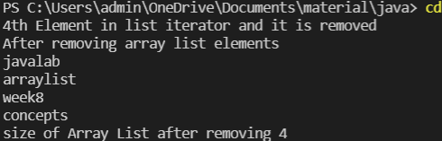

PROGRAM (C): -

AIM: Create an employee class containing at least 3 details along with Id, setters and getters. Insert the employee objects dynamically key as employee id and value as its corresponding object into a HashMap. Perform Id based search operation on the HashMap.

PROGRAM:

**import java.util.*;**

**public class week8c{**

**static class emp {**

**int eid;**

**String ename;**

**int eage;**

**void details(int eid, String ename, int eage ){**

**this.eid = eid;**

**this.ename = ename;**

**this.eage = eage;**

**}**

**int get_id(){**

**return eid;**

**}**

**String get_name(){**

**return ename;**

**}**

**int get_age(){**

**return eage;**

**}**

**}**

**public static void main(String s[]){**

**Scanner sc = new Scanner(System.in);**

**HashMap<Integer,emp> map = new HashMap<Integer,emp>();**

**System.out.println("Enter no of employees ");**

**int n = sc.nextInt();**

**for(int i=0;i<n;i++){**

**System.out.println("Enter employee name");**

**String name = sc.next();**

**System.out.println("Enter employee id");**

**int id = sc.nextInt();**

**System.out.println("Enter employee age");**

**int age = sc.nextInt();**

**emp e = new emp();**

**e.details(id,name,age);**

**map.put(id,e);**

**}**

**System.out.println("Enter the search id");**

**int r = sc.nextInt();**

**System.out.println("Employee name : "+map.get(r).get_name());**

**System.out.println("Employee id : "+map.get(r).get_id());**

**System.out.println("Employee age : "+map.get(r).get_age());**

**sc.close();**

**}**

**}**

OUTPUT:

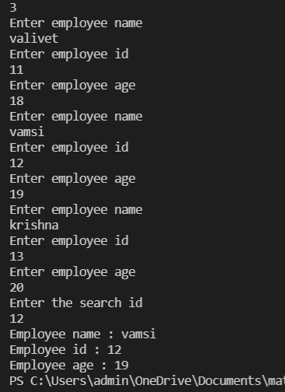

**Week 9**

PROGRAM (A): -

AIM: Write a program that reads file name from the user then displays information about that file, also read the contents from the file in byte stream to count number of alphabets, numeric values and special symbols. Write these statistics into another file using byte streams.

PROGRAM:

**import java.io.*;**

**import java.util.*;**

**class week91**

**{**

**public static void main(String[] args) throws IOException**

**{**

**int alpha,nums,spechar,ch;**

**alpha=nums=spechar=0;**

**File f1 = new File("input.txt");**

**FileInputStream fstream = new FileInputStream(f1);**

**InputStreamReader input = new InputStreamReader(fstream);**

**BufferedReader reader = new BufferedReader(input);**

**while((ch=reader.read())!=-1)**

**{**

**if(((ch>='a')&&(ch<='z'))||((ch>='A')&&(ch<='Z')))**

**alpha+=1;**

**else if((ch>='0')&&(ch<='9'))**

**nums+=1;**

**else**

**{**

**if(ch!=' ')**

**spechar+=1;**

**}**

**}**

**File f2 = new File("output.txt");**

**FileOutputStream fstream2 = new FileOutputStream(f2);**

**String stats="Numeric value count: " +nums+"\nAlphabet count: " +alpha+"\nSpecial character count: " +spechar;**

**byte b[] = stats.getBytes();**

**fstream2.write(b);**

**System.out.println("Numeric value count: " +nums);**

**System.out.println("Alphabet count: " +alpha);**

**System.out.println("Special character count: " +spechar);**

**}**

**}**

OUTPUT:

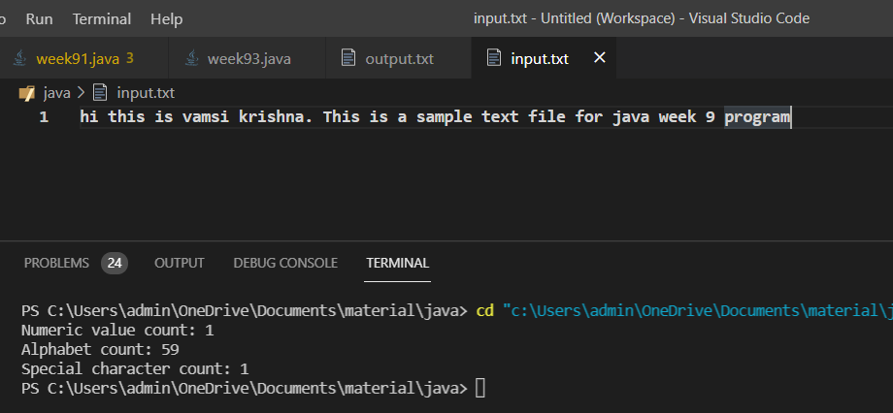

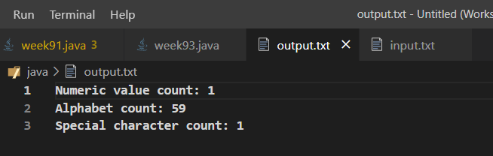

PROGRAM (B): -

AIM: Write a program that reads a CSV file containing a super market data containing product ID, Name, Cost and Quantity of sales and calculate the total revenue of the super market also sort the products in the order of their demand.

PROGRAM:

OUTPUT:

PROGRAM (C): -

AIM: Write a program that reads a text file containing some technical content and identify the technical terms and sort them alphabetically. Note: use a file containing stop words (general English and Grammar terms as many terms as possible)

PROGRAM:

**import java.io.*;**

**import java.util.Arrays;**

**public class week93**

**{**

**public static void main(String args[]) throws IOException**

**{**

**FileInputStream fis=new FileInputStream("input.txt");**

**FileWriter fw=new FileWriter("output.txt");**

**InputStreamReader isr=new InputStreamReader(fis);**

**BufferedReader br=new BufferedReader(isr);**

**String line;**

**String[] wordlist={};**

**while((line=br.readLine())!=null)**

**{**

**wordlist=line.split(" ");**

**}**

**Arrays.sort(wordlist);**

**for(String s:wordlist)**

**{**

**fw.write(s);**

**fw.write(" ");**

**}**

**fw.close();**

**br.close();**

**System.out.println("Check the output file");**

**}**

**}**

OUTPUT:

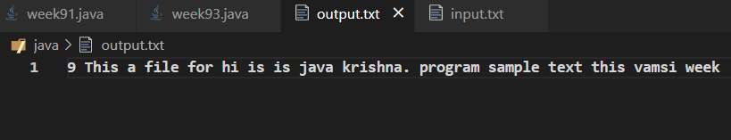

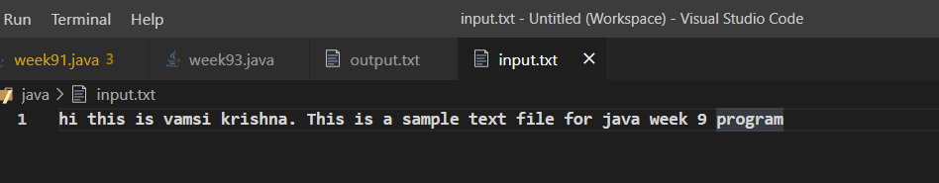

**Week 10**

PROGRAM (A): -

AIM: Write a program that reads two numbers from the user to perform integer division into Num1 and Num2 variables. The division of Num1 and Num2 is displayed if they are integers. If Num1 or Num2 were not an integer, the program would throw a Number Format Exception. If Num2 were Zero, the program would throw an Arithmetic Exception.

PROGRAM:

**import java.util.*;**

**class week10{**

**public static void main(String s[]){**

**Scanner sc = new Scanner(System.in);**

**try{**

**String num1 = sc.next();**

**String num2 = sc.next();**

**int n1 = Integer.parseInt(num1);**

**int n2 = Integer.parseInt(num2);**

**try{**

**float n = n1/n2;**

**System.out.println(n);**

**}**

**catch(ArithmeticException ex){**

**System.err.println("Division not possible");**

**}**

**}**

**catch(NumberFormatException ex){**

**System.err.println("Invalid format");**

**}**

**sc.close();**

**}**

**}**

OUTPUT:

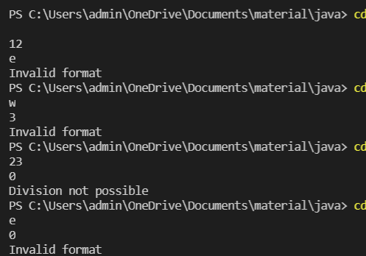

PROGRAM (B): -

AIM: Create a user defined exception

PROGRAM:

**import java.util.*;**

**public class week10b {**

**static class numberexception extends Exception{**

**public numberexception(){**

**System.out.println("Negitive integer sqrt not possible ");**

**}**

**}**

**public static void main(String s[]){**

**Scanner sc = new Scanner(System.in);**

**try{**

**int a = sc.nextInt();**

**if(a>=0){**

**System.out.println(Math.sqrt(a));**

**}**

**else{**

**throw new numberexception();**

**}**

**}**

**catch(numberexception ne){**

**ne.getMessage();**

**}**

**sc.close();**

**}**

**}**

OUTPUT:

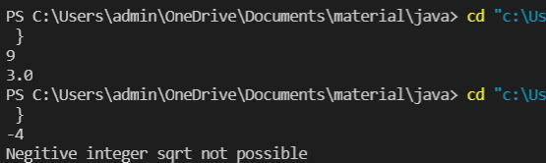

Week 11

**11) a)** Write a program that creates 3 threads by extending the Thread class. First thread displays “Good Morning” every 1 sec, the second thread displays “Hello” every 2 seconds and the third displays Welcome” every 3 seconds. (Repeat the same by implementing Runnable).

**Code:(Using thread extension):**

//Implementation using extends threads.

class Week11_a{

    public static void main(String... args){

        Good_Morning t1 = new Good_Morning();

        Hello t2 = new Hello();

        Welcome t3 = new Welcome();

        t1.start();t2.start();t3.start();

    }

}

class Good_Morning extends Thread {

    public void run(){

        for(int i = 0 ; i  < 5 ; i++){

            System.out.println("Good Morning");

            try{sleep(1000);}catch(Exception e){}

        }

    }

}

class Hello extends Thread {

    public void run(){

        for(int i = 0 ; i  < 5 ; i++){

            System.out.println("Hello");

            try{sleep(2000);}catch(Exception e){}

        }

    }

}

class Welcome extends Thread {

    public void run(){

        for(int i = 0 ; i  < 5 ; i++){

            System.out.println("Welcome");

            try{sleep(3000);}catch(Exception e){}

        }

    }

}

**Output:**

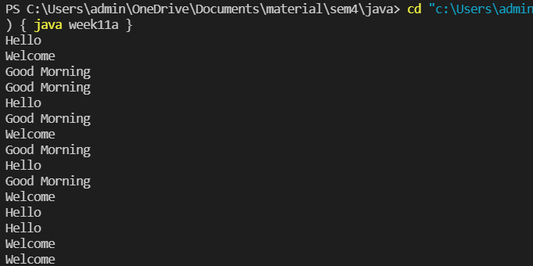

**Code:(Implementing Runnable )**

//implementing using runnable.

class Week11_a{

    public static void main(String... args){

        Good_Morning obj1 = new Good_Morning();

        Thread t1 = new Thread(obj1);

        Hello obj2 = new Hello();

        Thread t2 = new Thread(obj2);

        Welcome obj3 = new Welcome();

        Thread t3 = new Thread(obj3);

        t1.start();t2.start();t3.start();

    }

}

class Good_Morning implements Runnable {

    public void run(){

        for(int i = 0 ; i  < 5 ; i++){

            System.out.println("Good Morning");

            try{Thread.sleep(1000);}catch(Exception e){}

        }

    }

}

class Hello implements Runnable {

    public void run(){

        for(int i = 0 ; i  < 5 ; i++){

            System.out.println("Hello");

            try{Thread.sleep(2000);}catch(Exception e){}

        }

    }

}

class Welcome implements Runnable {

    public void run(){

        for(int i = 0 ; i  < 5 ; i++){

            System.out.println("Welcome");

            try{Thread.sleep(3000);}catch(Exception e){}

        }

    }

}

**Output:**



**11)b)** Write a program to illustrate Thread synchronization.

**Program: -**

class Week11_b{

    public static void main(String... args){

        Example ex = new Example();

        Synch t1 = new Synch(ex);

        Synch t2 = new Synch(ex);

        Synch t3 = new Synch(ex);

        System.out.println("Threads Before Synchronized :");

        t1.start();t2.start();t3.start();

    }

}

class Example {

    void display(){

        for(int i= 0 ; i < 5 ; i++){

           System.out.println(Thread.currentThread().getName()+" - "+i);

           try{Thread.sleep(2000);}catch(Exception e){}

        }

        synchronized(this){

        System.out.println("Threads after Synchronized :"+Thread.currentThread().getName());

            for(int i= 0 ; i < 5 ; i++){

           System.out.println(Thread.currentThread().getName()+" - "+i);

           try{Thread.sleep(2000);}catch(Exception e){}

        }}

    }

}

class Synch extends Thread{

    Example e;

    Synch(Example ex){

        this.e = ex;

    }

    public void run(){

        e.display();

    }

}

**Ouput:**

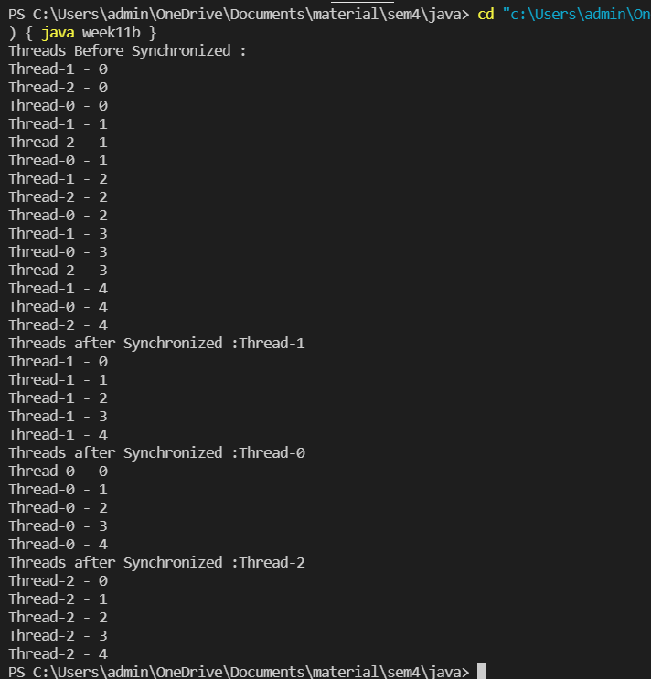

**Week 12**

**12)a)** Create a JApplet that displays a message which is scrolling from left to right and vice versa.

PROGRAM **:**

import java.awt.*;

import java.applet.*;

public class Week_12a extends Applet implements Runnable {

    String text;

    int x,y,flag;

    Thread t;

    public void init(){

        text = "J A V A";

        x = 10;y = 150;

        value = 1;

        t = new Thread(this);t.start();

    }

    public void update(){

        x = x + 10 * value;

        if (x > 260)

            value = -1;

        if (x < 100)

            value = 1;

    }

    public void run(){

        while(true){

            update();

            repaint();

            try{

                Thread.sleep(1000);

            }catch(Exception e){}

        }

    }

    public void paint(Graphics g){

        g.drawString(text,x,y);

    }

}

Html File:

<html>

    <head>

        <title>Scrolling Text</title>

    </head>

    <body>

        <applet code = "Week_12a.class" width = "300" height = "300"></applet>

    </body>

</html>

Output :

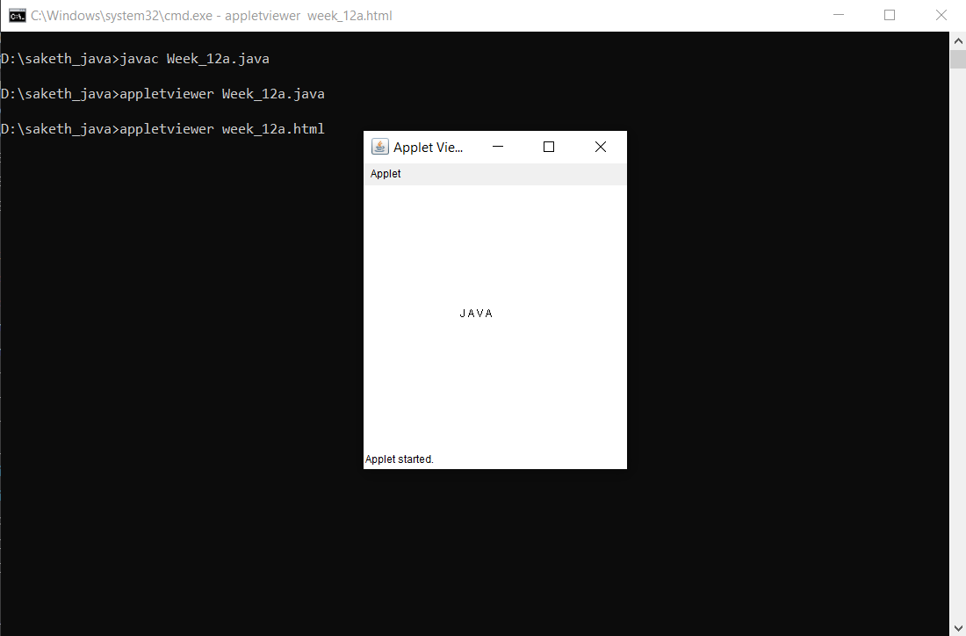

**12)b)** Write a program that displays a sample registration page using Swing controls use appropriate layout managers.

PROGRAM: -

import javax.swing.*;

import java.awt.*;

import java.awt.event.*;

class Week12_b extends JFrame{

    JLabel l1,l2,l3,l4,l5,l6,l7,l8,l9;

    JTextField tf1,tf2,tf3,tf4;

    ButtonGroup bg;

    JRadioButton rb1,rb2;

    JButton b1,b2;

    JPanel p;

    Font f1,f2;

    JPasswordField p1,p2;

    JTextArea ta;

    JCheckBox cb1;

    Week12_b(){

        //Fonts

        f1 = new Font(null,Font.BOLD,22);

        //labels

        l1 = new JLabel("Registration Form");l1.setFont(f1);

        l2 = new JLabel("First Name :");

        l3 = new JLabel("Last Email :");

        l4 = new JLabel("E - mail Id :");

        l5 = new JLabel("Password :");

        l6 = new JLabel("Confirm Password:");

        l7 = new JLabel("Phone No:");

        l8 = new JLabel("Gender :");

        l9 = new JLabel("Describe Yourself (100 words) :");

        //textFields

        tf1 = new JTextField(20);

        tf2 = new JTextField(20);

        tf3 = new JTextField(20);

        tf4 = new JTextField(20);

        //password fielsd

        p1 = new JPasswordField(20);

        p2 = new JPasswordField(20);

        //radio buttons

        rb1 = new JRadioButton("Male",false);

        rb2 = new JRadioButton("Female",false);

        bg = new ButtonGroup();

        bg.add(rb1);bg.add(rb2);

        JPanel p_g = new JPanel();

        p_g.add(rb1);p_g.add(rb2);

        //buttons.

        JPanel p_b = new JPanel();

        b1 = new JButton("Clear");b1.setBounds(120,5,100,30);

        b2 = new JButton("Register");b2.setBounds(270,5,100,30);

        p_b.setSize(500,40);

        p_b.add(b1);p_b.add(b2);

        //checkbox

        cb1 = new JCheckBox("I Accept the Terms and Conditions.");

        //layout

        GridBagConstraints g = new GridBagConstraints();

        p = new JPanel();

        p.setLayout(new GridBagLayout());

        //text area

        ta = new JTextArea(8,50);

        //grids.

        g.gridwidth = 2;

        g.insets = new Insets(10,0,20,0);

        g.gridx = 0;g.gridy = 0;p.add(l1,g);

        g.anchor = GridBagConstraints.LINE_START;

        g.gridwidth = 1;

        g.insets = new Insets(20,0,0,0);

        g.gridx = 0;g.gridy = 1;p.add(l2,g);

        g.gridx = 1;g.gridy = 1;p.add(tf1,g);

        g.gridx = 0;g.gridy = 2;p.add(l3,g);

        g.gridx = 1;g.gridy = 2;p.add(tf2,g);

        g.gridx = 0;g.gridy = 3;p.add(l4,g);

        g.gridx = 1;g.gridy = 3;p.add(tf3,g);

        g.gridx = 0;g.gridy = 4;p.add(l5,g);

        g.gridx = 1;g.gridy = 4;p.add(p1,g);

        g.gridx = 0;g.gridy = 5;p.add(l6,g);

        g.gridx = 1;g.gridy = 5;p.add(p2,g);

        g.gridx = 0;g.gridy = 6;p.add(l7,g);

        g.gridx = 1;g.gridy = 6;p.add(tf4,g);

        g.gridx = 0;g.gridy = 7;p.add(l8,g);

        g.gridx = 1;g.gridy = 7;p.add(p_g,g);

        g.gridx = 0;g.gridy = 8;p.add(l9,g);

        g.gridx = 0;g.gridy = 10;p.add(cb1,g);

        g.anchor = GridBagConstraints.LINE_END;

        g.gridx = 1;g.gridy = 11;p.add(p_b,g);

        g.gridwidth = 2;

        g.anchor = GridBagConstraints.LINE_START;

        g.gridx = 0;g.gridy = 9;p.add(ta,g);

        //ations

        b1.addActionListener(new ActionListener(){

            public void actionPerformed(ActionEvent e){

                tf1.setText("");tf2.setText("");tf3.setText("");tf4.setText("");

                p1.setText("");p2.setText("");bg.clearSelection();

                cb1.setSelected(false);ta.setText("");

            }

        });

        b2.addActionListener(new ActionListener(){

            public void actionPerformed(ActionEvent e){

        String pass1 = p1.getText() , pass2 = p2.getText();

        if((tf1.getText()).equals("")||(tf2.getText()).equals("")||(tf3.getText()).equals("")||(tf4.getText()).equals("")){

                    JOptionPane.showMessageDialog(null,"Please Fill Form Completely","Warning",JOptionPane.WARNING_MESSAGE,null);

                }

                else if(cb1.isSelected() == false){

                    JOptionPane.showMessageDialog(null,"Please Accept the Terms and Conditions.","Information",JOptionPane.INFORMATION_MESSAGE,null);

                }

                else if(pass1.equals(pass2) && !pass1.equals("")){

                    JOptionPane.showMessageDialog(null,"                Successful Registration","Success",JOptionPane.PLAIN_MESSAGE,null);

                }

                else{

                    p1.setText("");

                    p2.setText("");

                    JOptionPane.showMessageDialog(null,"Password Mismatch","Error",JOptionPane.YES_NO_OPTION,null);

                }

            }

        });

        //display

        add(p);

        setDefaultCloseOperation(JFrame.EXIT_ON_CLOSE);

        setTitle("Registration Form");

        setSize(600,700);

        setVisible(true);

        setLocationRelativeTo(null);

    }

    public static void main(String... s){

        new Week12_b();

    }

}

**Output:**

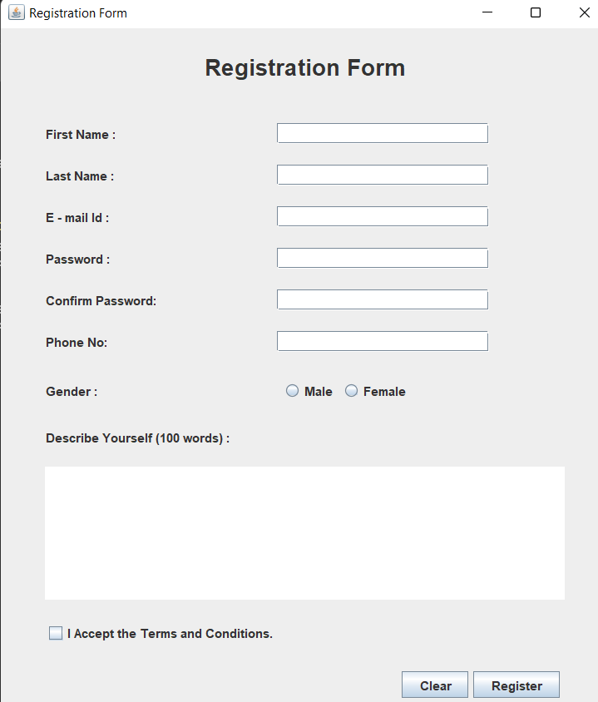

**12)c)** Write a program for handling mouse events with adapter classes.

PROGRAM: -

import java.awt.*;

import java.awt.event.*;

import javax.swing.*;

public class Week_12c{

    public static void main(String ... s){

        MouseAdapterEx e = new MouseAdapterEx();

    }

}

//Extending mouse adapter class.

class MouseAdapterEx extends MouseAdapter{

    JFrame f;

    MouseAdapterEx(){

        f = new JFrame("Mouse Adapter");

        f.setDefaultCloseOperation(JFrame.EXIT_ON_CLOSE);

        f.addMouseListener(this);

        f.setSize(400,400);

        f.setLocationRelativeTo(null);

        f.setVisible(true);

    }

    //function for what happens if mouse clicked.

    public void mouseClicked(MouseEvent me){

        Graphics g = f.getGraphics();

        g.setColor(Color.blue);

        g.fillRect(me.getX(),me.getY(),20,20);

    }

}

Output: -

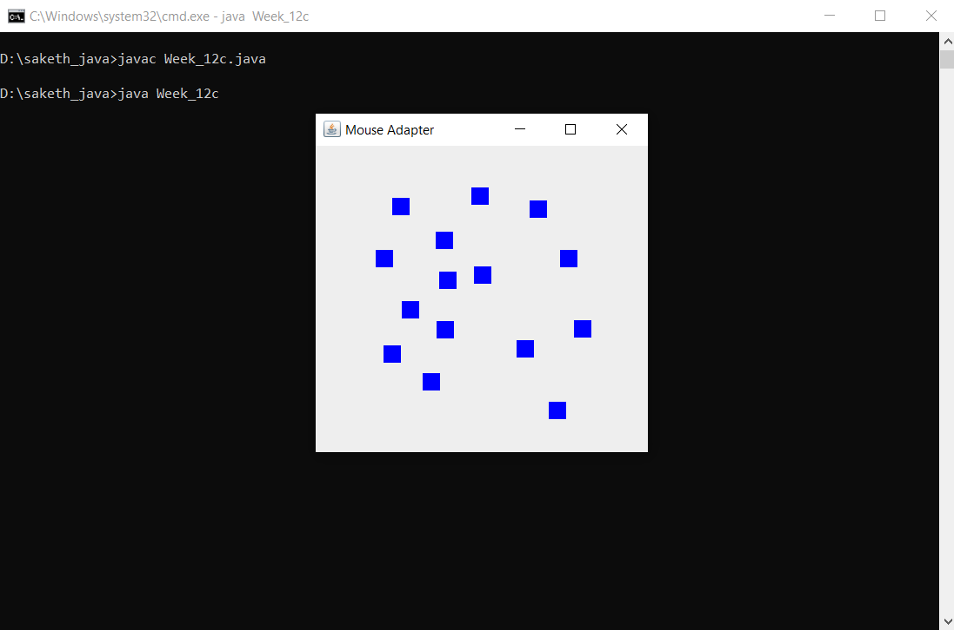

Week 13

**13)a)** create an interface containing 3 radio buttons named line, rectangle and oval. Based on the radio button selected, allow user to draw lines, rectangles or ovals as per the locations selected by the user.

PROGRAM

**Week_13a.java File**

import java.awt.*;

import java.awt.event.*;

import java.applet.*;

import javax.swing.*;

public class Week_13a extends Applet implements MouseMotionListener{

    JRadioButton rb1,rb2,rb3;

    ButtonGroup bg;

    Panel p1,p2;

    Label l,size_l;

    Button b1,b2;

    TextField tf1;

    int x;

    public void init(){

        setBackground(Color.red);

        //pannel 1

        p1 = new Panel(null);

        p1.setBackground(Color.blue);

        p1.setBounds(0,40,500,600);

        p1.addMouseMotionListener(this);

        //pannel 2

        p2 = new Panel(null);

        p2.setBackground(Color.white);

        p2.setBounds(530,40,300,600);

        //adding label.

        l = new Label("Choose :");

        l.setBounds(20,20,100,30);

        l.setFont(new Font("",Font.BOLD,22));

        p2.add(l);

        //adding button group.

        rb1 = new JRadioButton("Line");

        rb1.setBounds(40,80,60,20);

        rb2 = new JRadioButton("Rectangle",true);

        rb2.setBounds(40,125,100,20);

        rb3 = new JRadioButton("Oval");

        rb3.setBounds(40,165,60,20);

        bg = new ButtonGroup();

        bg.add(rb1);bg.add(rb2);bg.add(rb3);

        //Size Field.

        size_l = new Label("Change Size :");

        size_l.setBounds(20,210,100,20);

        size_l.setFont(new Font("",Font.BOLD,16));

        p2.add(size_l);

        b1 = new Button("-");

        b1.setBounds(130,210,20,20);

        tf1 = new TextField(5);

        tf1.setEnabled(false);

        tf1.setText("8");

        tf1.setBounds(160,210,50,20);

        b2 = new Button("+");

        b2.setBounds(220,210,20,20);

        x = Integer.parseInt(tf1.getText());

        b1.addActionListener(new ActionListener(){

            public void actionPerformed(ActionEvent ae){

                if(x!=0)

                    x -= 1 ;

                tf1.setText(String.valueOf(x));

            }

        });

        b2.addActionListener(new ActionListener(){

            public void actionPerformed(ActionEvent ae){

                x += 1 ;

                tf1.setText(String.valueOf(x));

            }

        });

        //adding to the applet.

        p2.add(rb1);p2.add(rb2);p2.add(rb3);

        p2.add(b1);p2.add(tf1);p2.add(b2);

        add(p1);add(p2);

    }

    public void mouseDragged(MouseEvent me){

        Graphics g = p1.getGraphics();

        g.setColor(Color.white);

        if(rb1.isSelected())

        g.drawLine(me.getX(),me.getY(),me.getX(),me.getY()+10);

        if(rb2.isSelected())

        g.fillRect(me.getX(),me.getY(),x,x);

        if(rb3.isSelected())

        g.fillOval(me.getX(),me.getY(),x,x);

    }

    public void mouseMoved(MouseEvent me){}

}

**paint.html File**

<html>

    <title>My Applets Demo</title>

    <body>

        <applet code = "Week_13a.class" width = "830" height = "610"></applet>

    </body>

</html>

Output :

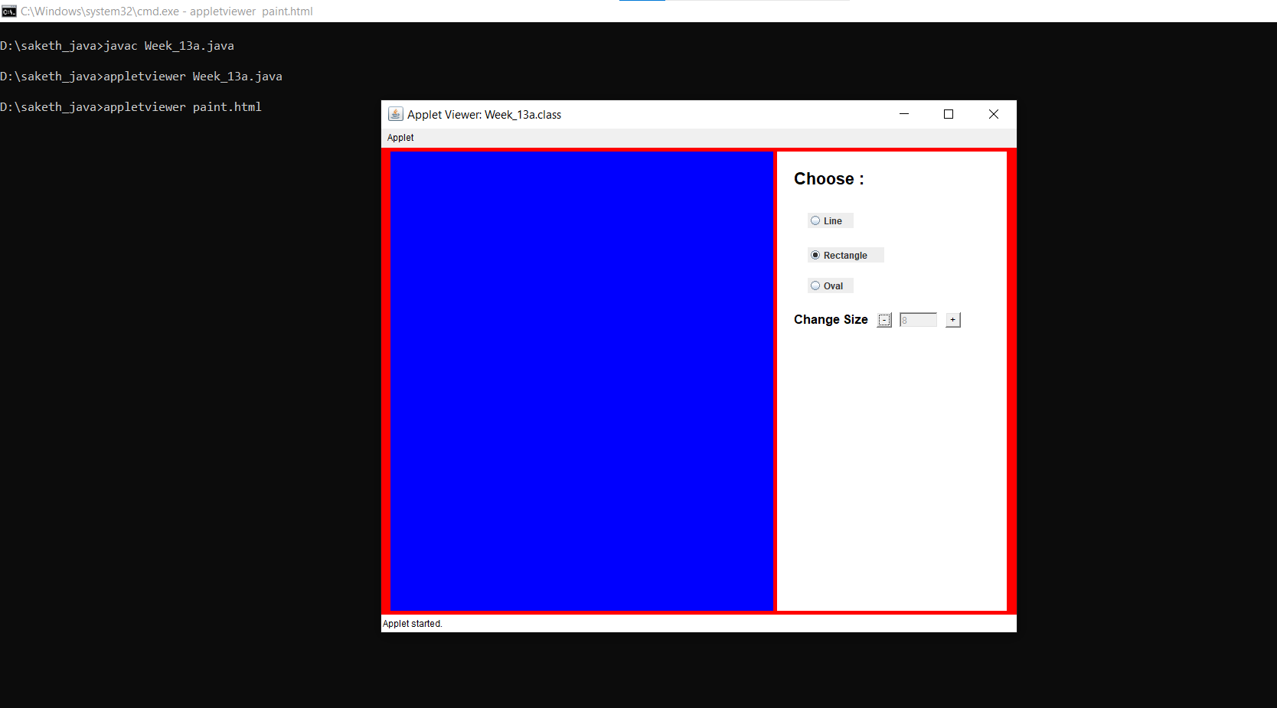

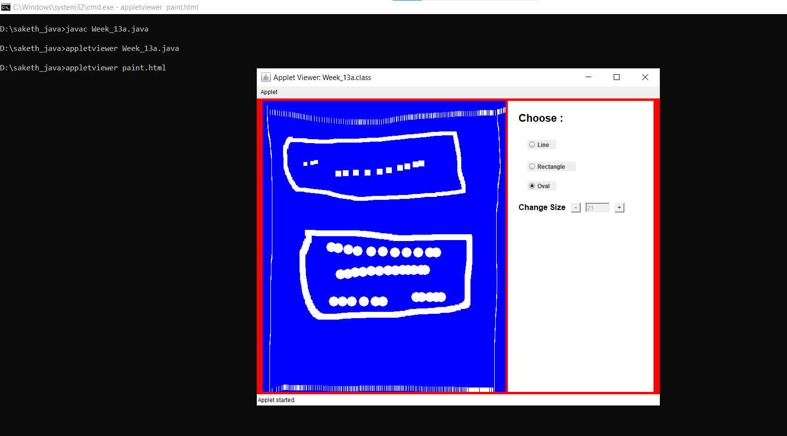

**13)b)** Write a program to create a Table inside a JFrame.

PROGRAM: -

import javax.swing.*;

import java.awt.*;

import java.awt.event.*;

public class Week_13b{

    JFrame f;

    JTable t;

    JScrollPane sp;

    JLabel l;

        Week_13b(){

         f = new JFrame("Exam Schedule");

         f.setDefaultCloseOperation(JFrame.EXIT_ON_CLOSE);

        String[] headings = {"Date","B.Tech VI sem","B.Tech IV sem"};

        String[][] data = {

            {"12-Aug-21" , "Lab Exam 1","Mid1 & Mid2 - sub 1"},

            {"13-Aug-21" , "Lab Exam 2","Mid1 & Mid2 - sub 2"},

            {"14-Aug-21" , "Lab Exam 3","Mid1 & Mid2 - sub 3"},

            {"16-Aug-21" , "Lab Exam 4","Mid1 & Mid2 - sub 4"},

            {"17-Aug-21" , "Lab Exam 5","Mid1 & Mid2 - sub 5"},

            {"18-Aug-21" , "Lab Exam 6","Mid1 & Mid2 - sub 6"},

            {"","",""},

            {"20-Aug-21" , "Mid1 & Mid2 - sub 1","Lab Exam 1"},

            {"21-Aug-21" , "Mid1 & Mid2 - sub 2","Lab Exam 2"},

            {"22-Aug-21" , "Mid1 & Mid2 - sub 3","Lab Exam 3"},

            {"23-Aug-21" , "Mid1 & Mid2 - sub 4","Lab Exam 4"},

            {"24-Aug-21" , "Mid1 & Mid2 - sub 5","Lab Exam 5"},

            {"25-Aug-21" , "Mid1 & Mid2 - sub 6","Lab Exam 6"},

        };

        t = new JTable(data,headings);

        sp = new JScrollPane(t);

        f.add(sp);

        f.setSize(500,500);

        f.setVisible(true);

    }

    public static void main(String... s){

       new Week_13b();

    }

}

Output :

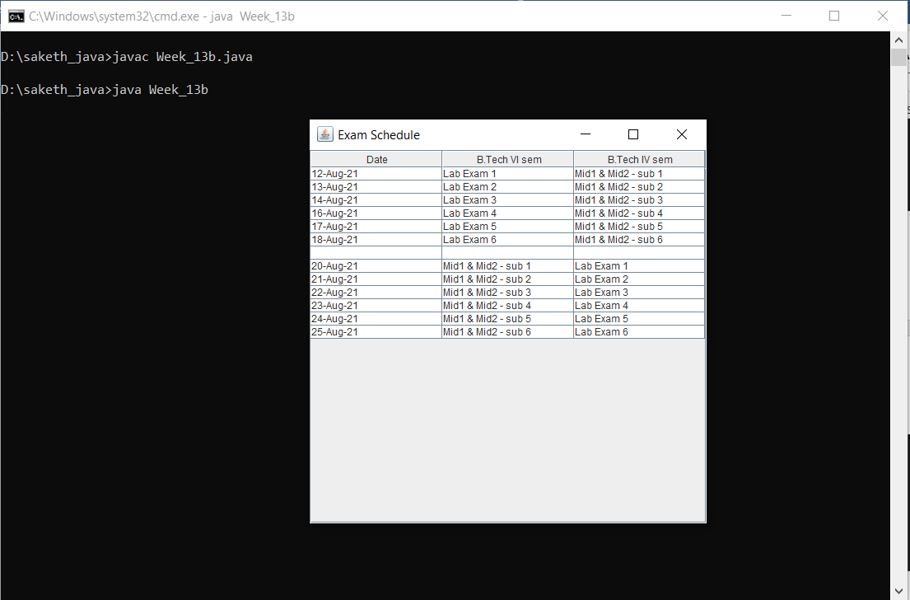

**13)c)** Create an interface that illustrates JFileChoose class and read CSV file containing employee data of various departments and display the records department wise on the interface.

PROGRAM: -

import javax.swing.*;

import java.awt.*;

import java.awt.event.*;

import java.io.*;

import java.util.*;

public class Week13_c {

    public static void main(String... s) throws Exception {

        Csv csv = new Csv();

    }

}

class Csv extends JFrame implements ActionListener{

    JComboBox<String> deptBox;

    JFileChooser fileChooser;

    JTextArea t;

    JButton b1,b2;

    String[][] fileInfo = new String[100][100];

    HashSet<String> deptSet = new HashSet<String>();

    int id = 0;

    Csv(){

        b1 = new JButton("Open File");

        b1.addActionListener(this);

        b1.setBounds(40,10,100,20);

        add(b1);

        b2 = new JButton("Generate");

        b2.setBounds(280,10,100,20);

        add(b2);

        b2.setVisible(false);

        t = new JTextArea(10,50);

        t.setBounds(10,40,450,200);

        add(t);

        deptBox = new JComboBox();

        deptBox.addItem("None");

        deptBox.setBounds(160,10,100,20);

        deptBox.setVisible(false);

        b2.addActionListener(new ActionListener(){

          public void actionPerformed(ActionEvent ae){

            if(deptBox.getSelectedItem() == "None"){

              t.setText("Select something");

            }else{

              String value = deptBox.getSelectedItem().toString();

              String data = "name | rollno | dept "+"\n";

              for(int i = 0 ; i < 100; i++){

                  if(value == fileInfo[i][2])

                  {

                    data = data + fileInfo[i][0] +" | "+fileInfo[i][1]+" | "+fileInfo[i][2]+"\n";

                  }

              }

              t.setText(data);

            }

          }

        });

        add(deptBox);

        setLayout(null);

        setDefaultCloseOperation(JFrame.EXIT_ON_CLOSE);

        setSize(500,400);

        setVisible(true);

        setLocationRelativeTo(null);

    }

  public void actionPerformed(ActionEvent ae){

    fileChooser = new JFileChooser(System.getProperty("user.dir"));

    int response = fileChooser.showOpenDialog(this);

    String line = "";

    if(response == JFileChooser.APPROVE_OPTION){

      deptBox.setVisible(true);

      b2.setVisible(true);

      try{

        File file = fileChooser.getSelectedFile();

        BufferedReader br = new BufferedReader(new FileReader(file));

        while((line = br.readLine())!=null){

          String dept[] = line.split(",");

          if(!deptSet.contains(dept[2]))

            deptBox.addItem(dept[2]);

          deptSet.add(dept[2]);

          fileInfo[id][0] = dept[0];

          fileInfo[id][1] = dept[1];

          fileInfo[id][2] = dept[2];

          id++;

        }

      }catch(Exception e){}

    }

  }

}

**Output:**

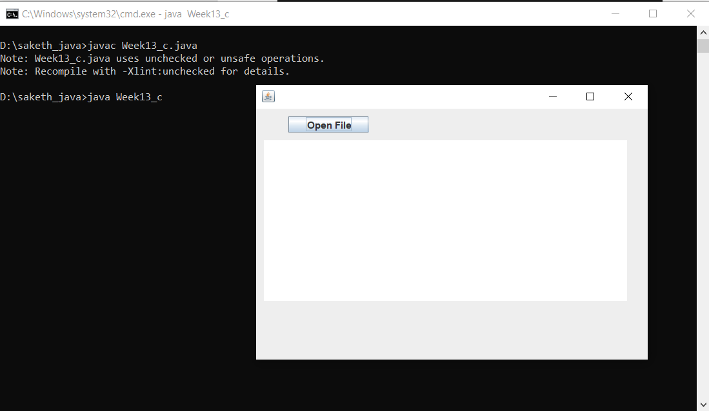

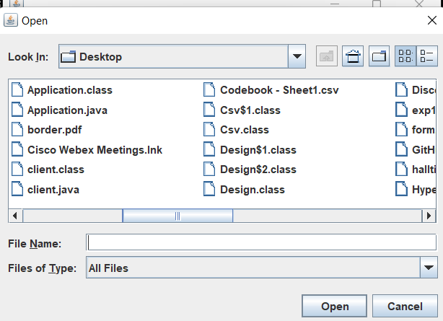

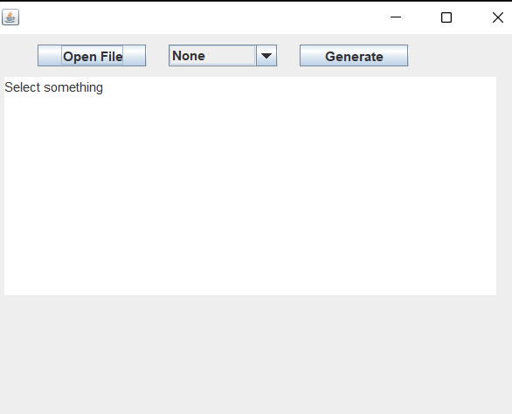

**Week 14**

**14)a)**For program 12) b) check all the fields filled or not, display success dialogue if all fields are filled with the help of ActionListener. Display respective error dialogue if a field is empty

PROGRAM: -

import javax.swing.*;

import java.awt.*;

import java.awt.event.*;

class Week12_b extends JFrame{

    JLabel l1,l2,l3,l4,l5,l6,l7,l8,l9;

    JTextField tf1,tf2,tf3,tf4;

    ButtonGroup bg;

    JRadioButton rb1,rb2;

    JButton b1,b2;

    JPanel p;

    Font f1,f2;

    JPasswordField p1,p2;

    JTextArea ta;

    JCheckBox cb1;

    Week12_b(){

        //Fonts

        f1 = new Font(null,Font.BOLD,22);

        //labels

        l1 = new JLabel("Registration Form");l1.setFont(f1);

        l2 = new JLabel("First Name :");

        l3 = new JLabel("Last Email :");

        l4 = new JLabel("E - mail Id :");

        l5 = new JLabel("Password :");

        l6 = new JLabel("Confirm Password:");

        l7 = new JLabel("Phone No:");

        l8 = new JLabel("Gender :");

        l9 = new JLabel("Describe Yourself (100 words) :");

        //textFields

        tf1 = new JTextField(20);

        tf2 = new JTextField(20);

        tf3 = new JTextField(20);

        tf4 = new JTextField(20);

        //password fielsd

        p1 = new JPasswordField(20);

        p2 = new JPasswordField(20);

        //radio buttons

        rb1 = new JRadioButton("Male",false);

        rb2 = new JRadioButton("Female",false);

        bg = new ButtonGroup();

        bg.add(rb1);bg.add(rb2);

        JPanel p_g = new JPanel();

        p_g.add(rb1);p_g.add(rb2);

        //buttons.

        JPanel p_b = new JPanel();

        b1 = new JButton("Clear");b1.setBounds(120,5,100,30);

        b2 = new JButton("Register");b2.setBounds(270,5,100,30);

        p_b.setSize(500,40);

        p_b.add(b1);p_b.add(b2);

        //checkbox

        cb1 = new JCheckBox("I Accept the Terms and Conditions.");

        //layout

        GridBagConstraints g = new GridBagConstraints();

        p = new JPanel();

        p.setLayout(new GridBagLayout());

        //text area

        ta = new JTextArea(8,50);

        //grids.

        g.gridwidth = 2;

        g.insets = new Insets(10,0,20,0);

        g.gridx = 0;g.gridy = 0;p.add(l1,g);

        g.anchor = GridBagConstraints.LINE_START;

        g.gridwidth = 1;

        g.insets = new Insets(20,0,0,0);

        g.gridx = 0;g.gridy = 1;p.add(l2,g);

        g.gridx = 1;g.gridy = 1;p.add(tf1,g);

        g.gridx = 0;g.gridy = 2;p.add(l3,g);

        g.gridx = 1;g.gridy = 2;p.add(tf2,g);

        g.gridx = 0;g.gridy = 3;p.add(l4,g);

        g.gridx = 1;g.gridy = 3;p.add(tf3,g);

        g.gridx = 0;g.gridy = 4;p.add(l5,g);

        g.gridx = 1;g.gridy = 4;p.add(p1,g);

        g.gridx = 0;g.gridy = 5;p.add(l6,g);

        g.gridx = 1;g.gridy = 5;p.add(p2,g);

        g.gridx = 0;g.gridy = 6;p.add(l7,g);

        g.gridx = 1;g.gridy = 6;p.add(tf4,g);

        g.gridx = 0;g.gridy = 7;p.add(l8,g);

        g.gridx = 1;g.gridy = 7;p.add(p_g,g);

        g.gridx = 0;g.gridy = 8;p.add(l9,g);

        g.gridx = 0;g.gridy = 10;p.add(cb1,g);

        g.anchor = GridBagConstraints.LINE_END;

        g.gridx = 1;g.gridy = 11;p.add(p_b,g);

        g.gridwidth = 2;

        g.anchor = GridBagConstraints.LINE_START;

        g.gridx = 0;g.gridy = 9;p.add(ta,g);

        //ations

        b1.addActionListener(new ActionListener(){

            public void actionPerformed(ActionEvent e){

                tf1.setText("");tf2.setText("");tf3.setText("");tf4.setText("");

                p1.setText("");p2.setText("");bg.clearSelection();

                cb1.setSelected(false);ta.setText("");

            }

        });

        b2.addActionListener(new ActionListener(){

            public void actionPerformed(ActionEvent e){

        String pass1 = p1.getText() , pass2 = p2.getText();

        if((tf1.getText()).equals("")||(tf2.getText()).equals("")||(tf3.getText()).equals("")||(tf4.getText()).equals("")){

                    JOptionPane.showMessageDialog(null,"Please Fill Form Completely","Warning",JOptionPane.WARNING_MESSAGE,null);

                }

                else if(cb1.isSelected() == false){

                    JOptionPane.showMessageDialog(null,"Please Accept the Terms and Conditions.","Information",JOptionPane.INFORMATION_MESSAGE,null);

                }

                else if(pass1.equals(pass2) && !pass1.equals("")){

                    JOptionPane.showMessageDialog(null,"                Successful Registration","Success",JOptionPane.PLAIN_MESSAGE,null);

                }

                else{

                    p1.setText("");

                    p2.setText("");

                    JOptionPane.showMessageDialog(null,"Password Mismatch","Error",JOptionPane.YES_NO_OPTION,null);

                }

            }

        });

        //display

        add(p);

        setDefaultCloseOperation(JFrame.EXIT_ON_CLOSE);

        setTitle("Registration Form");

        setSize(600,700);

        setVisible(true);

        setLocationRelativeTo(null);

    }

    public static void main(String... s){

        new Week12_b();

    }

}

**Output:**



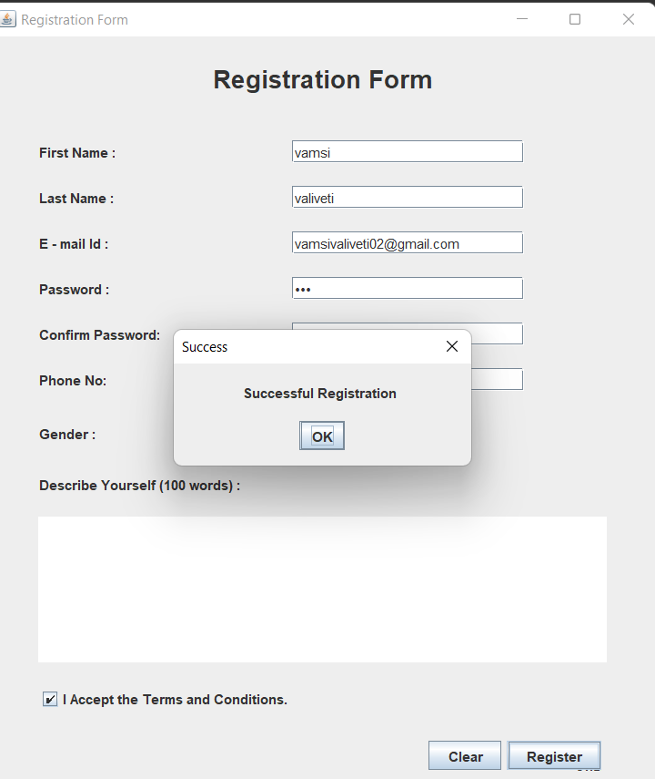

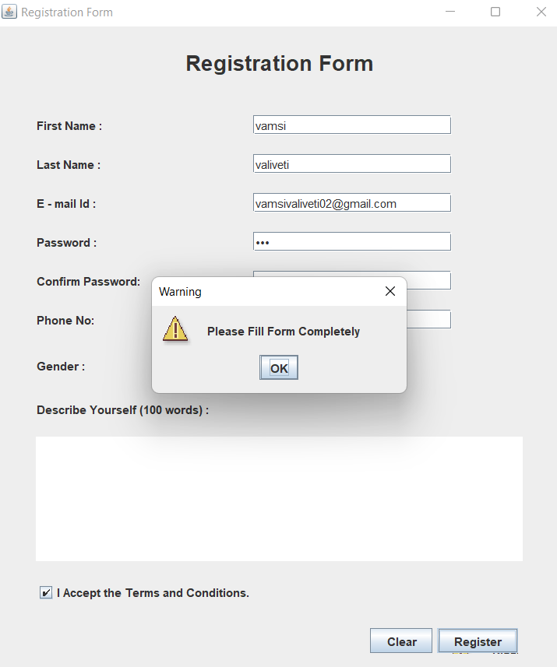

**14)b)** Write a program to create three JSliders where each represents colors RED, GREEN and BLUE. Each slider has a value from 0 to 255. The background color of the applet is set based on the values retrieved from each slider to form a color using the color class constructor. On sliding any slider, the background color of applet changes.

PROGRAM: -

import java.awt.*;

import java.applet.*;

import javax.swing.*;

import javax.swing.event.*;

import java.awt.event.*;

public class Week14b extends Applet implements ChangeListener{

    JSlider s1,s2,s3;

    JLabel l1,l2,l3,heading;

    int x,y,z;

    Color c;

    public void stateChanged(ChangeEvent e)

    {

            x = s1.getValue();

            y = s2.getValue();

            z = s3.getValue();

            c = new Color(x,y,z);

            setBackground(c);

    }

    public void init(){

        heading=new JLabel("sliders");

        heading.setBounds(60,30,300,20);

        //labels

        l1=new JLabel("RED");

        l2=new JLabel("GREEN");

        l3=new JLabel("BLUE");

        l1.setBounds(50,80,100,20);

        l2.setBounds(50,120,100,20);

        l3.setBounds(50,160,100,20);

        //sliders

        s1 = new JSlider(JSlider.HORIZONTAL,0,255,100);

        s2=new JSlider(JSlider.HORIZONTAL,0,255,100);

        s3=new JSlider(JSlider.HORIZONTAL,0,255,100);

        s1.addChangeListener(this);

        s2.addChangeListener(this);

        s3.addChangeListener(this);

        s1.setBounds(160,80,100,20);

        s2.setBounds(160,120,100,20);

        s3.setBounds(160,160,100,20);

        setBackground(new Color(s1.getValue(),s2.getValue(),s3.getValue()));

        setLayout(null);

        add(heading);

        add(l1);add(s1);add(l2);

        add(s2);add(l3);add(s3);

    }

}

Output:

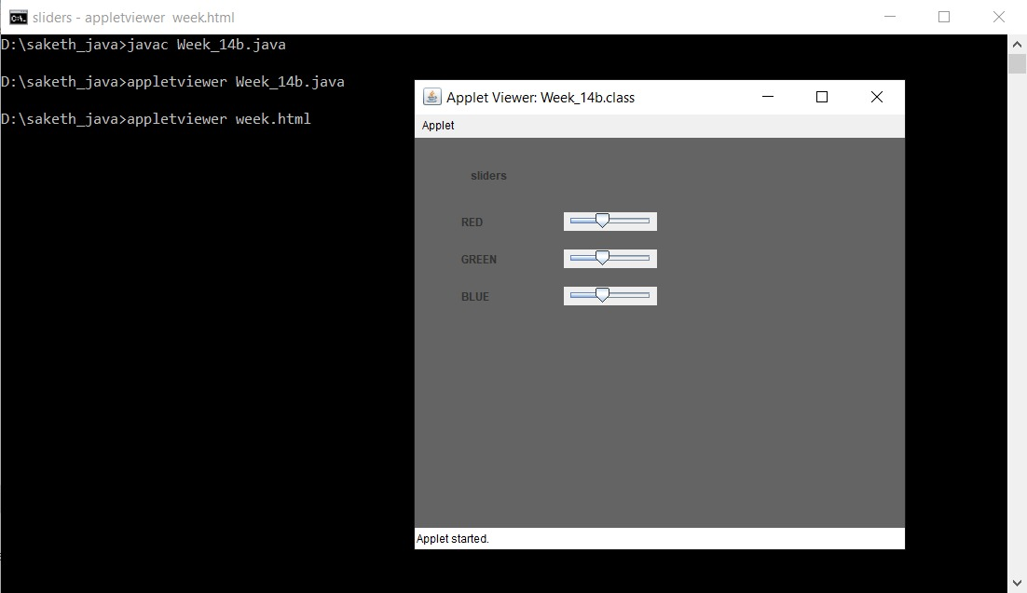

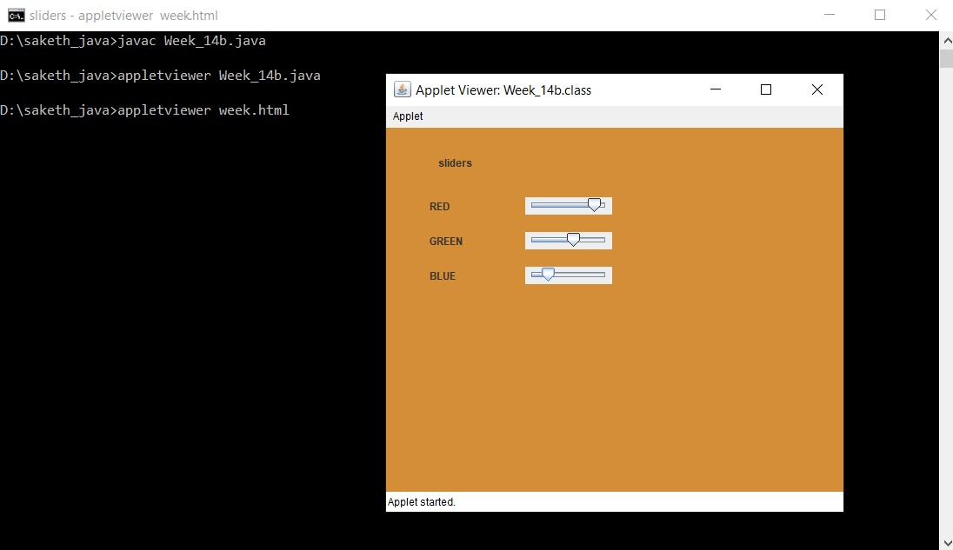

**Week 15**

**15)a)** Write a program that implements a simple client/server application. The client sends data to a server. The server receives the data, uses it to produce a result, and then sends the result back to the client. The client displays the result on the console. For ex: The data sent from the client is the radius of a circle, and the result produced by the server is the area of the circle.

PROGRAM: -

**Client Side**

import java.net.*;

import java.util.*;

import java.io.*;

class client

    public static void main(String... args) throws Exception {

        final String host = "localhost";

        final int port = 1064;

        Socket s = new Socket(host,port);

        Scanner sc= new Scanner(System.in);

        System.out.println("Enter radius to send to server :");

        int radius = sc.nextInt();

        OutputStreamWriter osr = new OutputStreamWriter(s.getOutputStream());

        PrintWriter p = new PrintWriter(osr);

        p.println(radius);

        osr.flush();

        InputStreamReader isr = new InputStreamReader(s.getInputStream());

        BufferedReader b = new BufferedReader(isr);

        String server_area = b.readLine();

        System.out.println("Area is :"+server_area);

        System.out.println("Server Disconnected");

    }

}

**Server Side**

import java.net.*;

import java.io.*;

import java.math.*;

public class server {

    public static void main(String... args) throws Exception {

        System.out.println("Server Started");

        int port = 1064;

        ServerSocket server_socket = new ServerSocket(port);

        System.out.println("Server is wqaiting for the client");

        Socket socket = server_socket.accept();

        System.out.println("Client connected to the server");

        InputStreamReader isr = new InputStreamReader(socket.getInputStream());

        BufferedReader b = new BufferedReader(isr);

        String client_radius = b.readLine();

        int r = Integer.parseInt(client_radius);

        System.out.println("Client Data :"+client_radius);

        Double area = (Math.PI)*r*r;

        OutputStreamWriter osw = new OutputStreamWriter(socket.getOutputStream());

        PrintWriter pw = new PrintWriter(osw);

        pw.println(area);

        pw.flush();

    }

}

Output:

